Job Description
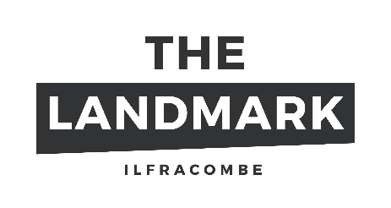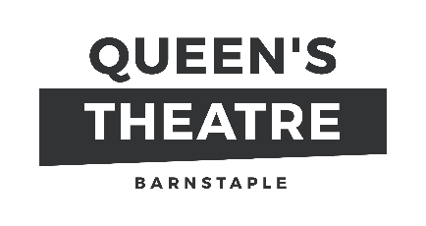
Job Title Speak Up Artist – Freelance
Responsible to Speak Up Project Manager
Place of work Across North Devon Schools, as required
Fee £300/day, £150/half day
Contract Freelance

Selladoor Venues operates the Queen’s Theatre and the Landmark as well as other venues across the UK. We aim to work with partners across the region to deliver creative practice in our outreach activities of the highest standards. The Freelance Speak Up Artists will work with young people across North Devon in partner schools.
We are now looking to extend our database of artists and practitioners interested to work with students in our partner schools.
Speak Up is a new secondary school programme that aims to inspire a movement of young people, who want to speak up about the issues that matter to them – in their schools, their communities and nationally. Young people will work collaboratively with their teachers, artists, local arts organisations to make local artworks and creative projects. This innovative programme, led by the National Theatre, is developing a network that will comprise 55 schools across the UK, working alongside 11 theatres and venues.
Speak Up is a co-created programme where young people, teachers and artists are equal partners. We are looking for a team of artists who are available to run workshops to share their skills and support young people, aged 11-15, to become the leaders of the future, putting them at the heart of the creative process and decision making. We are looking for artists with experience in all areas of creative practice – visual arts, dance, theatre and media arts - to deliver and facilitate a programme of workshops in Speak Up schools over the next three years.
Artist Specification
ESSENTIAL | DESIRABLE
- Experience and knowledge of one or more specific art form  - Excellent communication skills and ability to build strong relationships with students and partners  - Positivity and enthusiasm with a desire to engage and empower young people, and a genuine commitment to understanding factors affecting their lives  - Ability to problem solve and use your initiative to adapt to situations as required to deliver projects as necessary  - Willingness to undertake a DBS check and attend Safeguarding training | - Experience of working with and facilitating young people and in creating co-created work with young people  - Understanding of evaluation and research methodologies  - Experience of working with vulnerable groups, within both formal and informal education  - Inclusive practice and experience working with SEN/D and neurodiverse students, students with EAL  - Understanding of the education system and school settings

Getting Involved
If you would like to join our database of workshop leaders then please send your CV with a covering letter to steve.gear@selladoorvenues.com
We will be running an information evening for interested artists about the project in the coming weeks.
For more information about the project and the funders, please see Speak Up | National Theatre

