Job Description

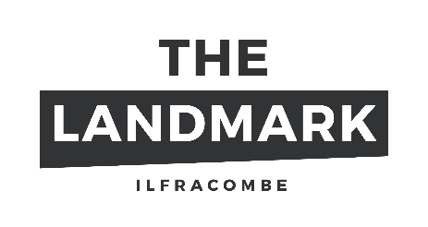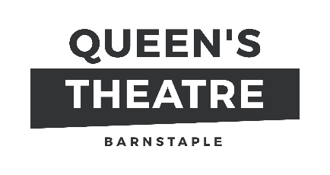

Job Title Speak Up Rep - Freelance
Responsible to Speak Up Project Manager
Place of work Across North Devon Schools, as required
Fee £150/day, £75/half day
Contract Freelance

Selladoor Venues operates the Queen’s Theatre and the Landmark as well as other venues across the UK. We aim to work with partners across the region to deliver creative practice in our outreach activities of the highest standards. The Freelance Speak Up Artists will work with young people across North Devon in partner schools.
We are now looking to extend our database of artists and practitioners interested to work with students in our partner schools.
Speak Up is a new secondary school programme that aims to inspire a movement of young people, who want to speak up about the issues that matter to them – in their schools, their communities and nationally. Young people will work collaboratively with their teachers, artists, local arts organisations to make local artworks and creative projects. This innovative programme, led by the National Theatre, is developing a network that will comprise 55 schools across the UK, working alongside 11 theatres and venues.
Speak Up is a co-created programme where young people, teachers and artists are equal partners. We are looking for a team of artists who are available to run workshops to share their skills and support young people, aged 11-15, to become the leaders of the future, putting them at the heart of the creative process and decision making. We are looking for artists with experience in all areas of creative practice – visual arts, dance, theatre and media arts - to deliver and facilitate a programme of workshops in Speak Up schools over the next three years.

Job Purpose - The Role of the Speak Up Rep
We are looking for artists to deliver and facilitate weekly workshops in Speak Up schools for ten weeks. This role is pivotal in order to get to know both the school and the young people and to listen to their interests, ambitions and creative ideas.
The role will work closely with the Speak Up Project Manager to design and facilitate sessions that allow young people to take ownership of their own artistic interests.
It is expected this role will also spend time embedding themselves in the school community. This may be through speaking at assemblies, spending time with students in lunch and break time, shadowing lessons and generally hanging out. This is to get to know the school, staff and young people outside of the Speak Up sessions and to gain a deep understanding of the culture of the school.
The Explore phase will shape the next phases of work within the school and will inform what artist(s) will deliver sessions in the school, what creative work the young people would like to make and how they would like Speak Up to be integrated into their school more widely.

Main Duties and Responsibilities
- To design and deliver weekly co-creation workshops in a school setting
- To get to know the school ethos outside of the workshops during assemblies, at lunch time, break time and through shadowing lessons etc
- Support young people to develop their voice and ideas within Speak Up sessions. This may include recommending additional artists to lead sessions with the group in consultation with the Speak Up Project Manager, teachers and young people
- Where necessary, to lead on the recruitment of young people to the sessions through assemblies, taster workshops, videos, form visits
- To complete a short session report after each session
- To capture data from the sessions and conversations that happen in the school which will feed into the evaluation process
- To support with the shaping of the next phases of Speak Up in the school with the young people and teacher(s)
- To feedback to the Project Manager on progress of the programme
- To attend a reflective session with the schoolteachers and Speak Up Project Manager termly (in person or online)
- Represent the vision of Speak Up to enable young people to realise their ideas within their school and wider community
- Support the young people with pastoral care needs where appropriate and inform the Project Manager and teacher of any concerns

Artist Specification
ESSENTIAL | DESIRABLE
- Experience of working with and facilitating young people and in creating co-created work with young people  - Excellent communication skills and ability to build strong relationships with colleagues and partners  - Understanding of the differing needs of diverse groups of young people, and the potential barriers to learning  - Commitment to working in a collaborative and equitable way within the Speak Up ethos  - Understanding the professional needs of teachers and youth professionals in connection with the delivery of arts projects  - Positivity and enthusiasm with a desire to engage and empower young people, and a genuine commitment to understanding factors affecting their lives  - Ability to problem solve and use your initiative to adapt to situations as required to deliver projects as necessary  - Experience and knowledge of a specific or more than one specific art form(s)  - Willingness to undertake a DBS check and attend Safeguarding training | - A strong understanding of evaluation and research methodologies  - Ability to work under pressure and prioritise workload to deliver on outcomes and agreed deadlines  - Experience of working with vulnerable groups, within both formal and informal education  - Inclusive practice and experience working with SEN/D and neurodiverse students, students with EAL  - Understanding of the education system and school setting(s)  - Knowledge of the local area in which you will be engaging  - Knowledge of good safeguarding practice  - IT skills including Outlook, Word and Excel; Zoom and/or Microsoft Teams

Getting Involved
If you would like to join our database of workshop leaders then please send your CV with a covering letter to steve.gear@selladoorvenues.com
We will be running an information evening for interested artists about the project in the coming weeks.
For more information about the project and the funders, please see Speak Up | National Theatre

